Capstone Project Weekly Progress Report

|  |  |
| --- | --- |
| Semester | Fall 2021 |
| Course Code | AML 3406 |
| Section | 2 |
| Project Title | Restaurant Recommendation Chatbot |
| Group Name | Group 3 |
| Student Name/Student ID | Vignesh Kumar Murugananthan (C0793756) |
| Reporting Week | Week 2 – 09/18/2021 |
| Faculty Supervisor | Vahid Hadavi |

# **Tasks Outlined in Previous Weekly Progress Report**

Selected few project ideas by discussing with group members in a breakout session and the project's scope. Identified the use cases and submitted them for instructor approval.

# **Progress Made in Reporting Week**

The instructor approved the project, and in the breakout session, we were asked to discuss the different approaches and develop a project plan. The project plan was developed using a grant chart that includes dates and milestones with each group member's responsibilities and roles. A calendar was created and agreed upon for a team meeting two days a week.

# **Difficulties Encountered in Reporting Week**

Have to start researching for the literature review as a team and develop possible solutions to implement the viable project and meet the project constraints. Finding the best suitable algorithm for chatbot and the related datasets for different restaurants were few difficulties we faced in the reporting week. Will adhere to the points as per the instructor's feedback and get to complete the deliverables.

# **Tasks to Be Completed in Next Week**

Have to build an overall architecture about the project plan and come up with the analysis about the algorithms that can be used to build an efficient chatbot and the data collection, which is an integral part of this project.

# **Team Project Plan**

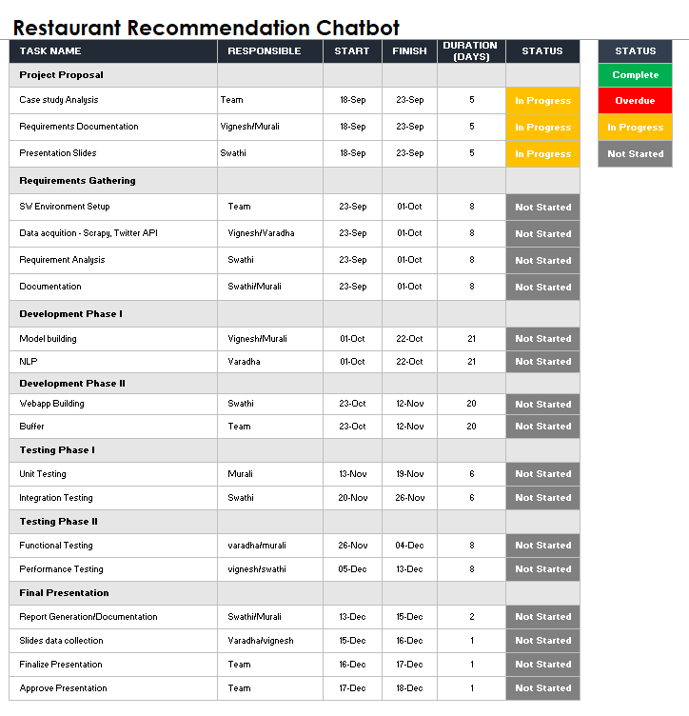

# **Personal Plan**

* Build an overall Architecutre
* Requirements Documentation
* Data acquition - Scrapy, Twitter API
* Model building
* Performance Testing